- PURPOSE:

This DOCUMENT provides the ESD/EOS Operating Standard that shall be followed by those in which ESD devises are handled, processed, and/or manufactured. These Operating Standards are intended to be used in developing and improving their ESD/EOS programs. This document was developed based on Industry Standards, Best Practices, and selected procedures.

- ACTIVITIES AFFECTED:

Manufacturing (including Joint Ventures)
Component Suppliers (packaging related only)
Manufacturing, Engineering, and Process Support

- FORMS USED:

ESD/EOS Operating Standard Assessment Survey (Form Name: ESD/EOS Survey)

- RELATED REFERENCES/PROCEDURES:

British Standards – BS EN 100015-1 1992
Electronic Industries Association EIA-625 – ANSI/EIA-625-1994
ESD Association Standards & Documents

- DEFINITIONS:

Manufacturing Plants: Manufacturing plants that use or handle ESD/EOS sensitive components and/or subassemblies.

5.1 Carrier, Tote, Bin: A holder for ESDS parts and devices that facilitates handling during processing, production and testing operation and protects parts under transport. ESDS devices are not to be transported in an unprotected mode.

  - Earth Ground:

- A conducting connection, whether intentional or accidental, between an electrical circuit or equipment and the earth, or to some conducting body that serves in place of earth (e.g. conductive flooring.)
- The position or portion of an electrical circuit at zero potential with respect to the earth.
- A conducting body, such as the earth used as a return path for electric currents and as an arbitrary zero reference point.

  - Electrostatic Discharge Sensitive Device (ESDS): A discrete device, integrated circuit, assembly or sub assembly that may be damaged by electric fields or electrostatic discharge encountered in routine handling, testing, and transit.

  - Equipment Ground:

  - The ground point at which the equipment ground connector is bonded to any piece of equipment, at the equipment end of the conductor.
  - The entire low-impedance path from a piece of electric equipment to a hard-ground electrode.
  - The third wire (green) of an AC Power receptacle.

  - EOS: Electrical Overstress: The exposure of an item to a current or voltage beyond its maximum ratings. This exposure may, or may not, result in a catastrophic failure.

  - ESD: Electrostatic Discharge: The rapid, spontaneous transfer of electrostatic charge between bodies at different electrostatic potentials.

  - ESD Common Point Ground: A designated connection, location, or assembly used on a ESD protective material, or device, that is intended to accommodate electrical connection from the devise to ESD ground. Also known as EBP (Earth Bonding Point).

  - ESD Footwear: Static control coverings for the human foot that have properties to dissipate static charge from the human body when used in conjunction with a static control floor or floor surfaces. Heel straps are not included in ESD Footwear (see Heel Strap definition).

  - ESD Ground: The point, electrodes, buss bar, metal strips, or other system of conductors that form a path from a statically charged person, or object, to earth ground.

  - ESD Protected Area (EPA): An area in which electrostatic discharge sensitive devices can be handled with minimum risk of damage to the sensitive part. The damage may be a result of electrostatic discharge or fields.

  - ESD Protective Packaging: A packaging system that provides electrostatic shielding and limits Triboelectric charging for ESDS devices.

  - Floor Mats: A defined, mobile section of static dissipative material which is electrically connected to earth ground and used to dissipate static charges by grounding personnel, equipment, and/or other objects contacting the floor material. The floor mat, placed over the existing floor material, controls the generation and accumulation of static charges.

  - Heel Straps: An assembled device, which fastens onto the heel of a person’s show and is used to drain static charges from the wearer to earth ground. A heel strap consists of a band, which fits over the shoes’ heel and a separate strap worn in contact with a person’s skin. Note: If heel straps are used in a facility, a person is required to wear two heel straps (i.e., one for each foot).

  - Ionizer: A device that generates positive and/or negative ions, which are used to neutralize unbalanced charges. Ionizers shall be self-balancing.

  - Materials – ESD Protective Material: A material capable of one or more of the following characteristics limiting the generation of static electricity (antistatic), rapidly dissipating electrostatic charge over its entire surface, or volume (static dissipative), or providing shielding from ESD spark, discharge, or electrostatic fields (conductive static shielding). ESD protective materials are classified in accordance with their electrical prosperities as static dissipative, conductive, or static shielding. Antistatic materials are not defined by electrical properties.

  - Material, Antistatic: A material exhibiting properties that minimize charge generation when rubbed against, or separated from, the same, or other materials. Antistatic materials resist Triboelectric charging, but allow a static charge to penetrate. Antistatic materials are often specified in terms of surface Resistivity. A material’s antistatic property is not necessarily correlated with its Resistivity and cannot be used as a total measurement of a material’s antistatic property. A material’s antistatic property is affected by many factors such as age, wear, contamination, and humidity.

Materials with Resistivity Properties:
    - electrostatic shielding materials: materials exhibiting the following characteristics: Surface Resistivity, 1 x 10⁴ ohm/sq

    - electrostatic conductive materials: materials exhibiting the following characteristics: 1 x 10³ ohm/sq < Surface Resistivity < 1 x 10⁶ ohm/sq

    - electrostatic dissipative materials: materials exhibiting the following characteristics: 1 x 10⁵ ohm/sq < Surface Resistivity < 1 x 10¹² ohm/sq

    - insulative materials: materials exhibiting the following characteristics: 1 x 1012 ohm/sq < Surface Resistivity

  - Resistance to Ground (Grounding Resistance): The total resistance from any given point in an electrically conductive path to the grounding electrode.

  - Surface Resistivity (ps): The surface Resistivity is the resistance between two opposite sides of a square and is independent of the size of the square or its dimensional units. Surface Resistivity is expressed in ohms/square.

  - Table Mats: A defined, mobile section of static dissipative material, which is electrically connected to earth ground and used to dissipate static charges by grounding personnel, equipment, and/or other objects contacting the table top work surface material. The tablemat, placed over the existing table material, controls the generation and accumulation of static charges.

  - Wrist Strap: An assembled device worn around the wrist that is intended to connect the user to a Groundable Point through skin contact while allowing movement within the extended length of the wrist strap’s cord. Each wrist strap shall use a discrete current-limiting resistor, usually 1 mega ohm in value, for personnel safety purposes.

6.0 Organizational Structure:

People are the greatest source of ESD generation and therefore all personnel shall have a fundamental responsibility to follow the precautions set in the Operating Standards. It is the responsibility of all those involved with ESDS devices to be aware of the ESD threat to the electronic products reliability. Personnel shall notify the President of any aspects that could be considered non-compliant to the Operating Standards requirements and make suggestions for corrective action, when appropriate. The Organizational Structure to support the ESD/EOS Operating Standards (not necessarily a reporting relationship, but communication and support channels), along with

Roles and Responsibilities to support the disciplines of ESD/EOS protection, are listed as follows:

        - ESD Coordinator: The organization shall have an ESD Coordinator who is an authoritative ESD/EOS consultant. He/she shall also support affected activities in ESD/EOS issues. The coordinator at Fancort is the company President.

        - ESD/EOS Team: Composed of the Lead Forming Services Supervisor, QA Manager, Auditing Manager, and President.

  - ESD Team:

The purpose of this team is to identify and define ESD areas; address ESD issues identified through internal and/or external audits and ensure implementation of corrective actions. The QA Manager from the ESD Team shall devote enough time to perform the following functions as appropriate:

1) Identifying timely and effective corrective actions for local audits and ongoing ESD/EOS issues.

2) Perform local ESD audits (See Table 3 for recommended frequencies)

3) Record and report ESD audit results to affected personnel and to the local ESD committee.

4) Develop and coordinate deployment of local ESD/EOS Training.
5) Keep up to date on new technologies and advancements in the ESD industry, as applicable.

6) Keep latest versions of standards applicable to this Operating Standard.

7) Continuously improve their local ESD program.

8) Member of ESD/EOS Best Practice Team.

9) Review Component Database (CDB, http://achp31.pto.ford.com:9000/cdb/owa/cdb_web.start_up) to identify components not meeting 2000 V. HBM/200 V.MM ESD Sensitivity Requirement, that are being used at the affected facility. Manufacturing plants are to develop local procedures to identify such components.

10) Routine floor and/or floor mat conductivity measurements (this responsibility shall be shared with Plant Maintenance).

11) Enforce compliance to ESD/EOS Operating Standard by performing the above listed activities.

12) Track effectiveness of ESD/EOS Program through local measurables over time.

  - Area Classification per ESDS Devices Sensitivity: The following is a classification of areas according to ESDS devices sensitivity, as they relate to components, subassemblies, and or modules.

NOTE: Area classification shall be clearly indicated and formally documented (i.e. Plant Layout with color coded area classifications and/or indication of ears by exception).

Class 0. Electrostatic Discharge Sensitivity Range: 0 Volts to 500 volts Color: RED

Class 1. Electrostatic Discharge Sensitivity Range: 501 Volts to 2,000 Volts Color: YELLOW/ORANGE

Some examples of device types:

- Microwave Devices (Schottky Barrier Diodes, Detector Diodes>1 Ghz
- Discrete Metal Oxide Semiconductor Field Effect Transistors (MOSFET) Devices
- Surface Acoustic Wave Devices (SAW)
- Junction Field Effects Transistors (JFETS)
- Charged Couple Devices (CCDs)
- Precision Voltage Regulators
- Operational Amplifiers
- Hybrid Modules and Circuits Utilizing Class 1 mentioned Devices
- Silicon Controlled Amplifiers

Class 2: Electrostatic Discharge Sensitivity Range:
2,001 Volts and Up Color: BLUE

Some examples of device types:

- Discrete and Integrated Devices if classified for higher ESD sensitivity (e.g. MOSFET, JFET, OP.AMPs)
- Thin Film Resistors
- Resistor Networks
- Low Powered Bipolar Transistors
- General Purpose Silicon Rectifiers
- Optoelectronic Devices
- Resistor Chips
- Piezoelectric Crystals
- Capacitors
- All other Microelectronics Devices not included in other classes

  - Area Classification:

Table 1 Class Identification Areas: The items listed in Table 1 are to be used at the facility, per each area’s classification.

Personnel Attire | Class 0  (0 – 500)  Volts | Class 1  (501 – 2,000)  Volts | Class 2  (2,001 & Up)  Volts
Wrist Straps (1M Ω resistor in series | R | R | R
Continuous Monitored Workstation | R | O | N
Wrist Strap Tester | R | R | R
Static Dissipative Floors or Floor Mats | R | R¹ | O
Heel Straps or ESD Footwear | R² | R² | O
Grounded Chairs and/or Stools | R² | O | O
Conductive Smocks | R | O | O
Conductive Gloves and/or Finger Cots | R³ | O | N

Work Areas | Class O  (0-500)  Volts | Class 1  (501-2000)  Volts | Class 2  (2,001 & Up)  Volts
Dissipative Table Tops & Mats | R | R | R
Grounded Tip Soldering Irons | R | R | O
Conductive Solder Suckers | R | R | O
Static Sensors (hand-held) – ESD coordinator &/or auditor required to possess | R | R | R
Megohmmeter w/NFPA 5 lb. Electrode – ESD coordinator */or auditor required to possess | R | R | R

Protective Packaging  &  Transportation | Class O  (0-500)  Volts | Class 1  (501-2000)  Volts | Class 2  (2,001 & Up)  Volts
Static Shielding Bags | R | R | R
Conductive Foam Sheets (shunts) | R | R | 0
Conductive Tote Boxes | R | R | R
Conductive Magazines | R | R | R
ESD Safe Transfer Carts | R | R | R

Facility | Class O  (0-500)  Volts | Class 1  (501-2000)  Volts | Class 2  (2,001 & Up)  Volts
Relative Humidity Control | 0 | 0 | N
Local Air Ionization | R⁴ | R | 0

KEY: REQUIRED (R) OPTIONAL: (O) NOT REQUIRED (N)

By these Operating Discretion of Local
Standards ESD Coordinator

R¹: Required only if the operation prevents the usage of a wrist strap (e.g. operator is mobile). If heel straps are used in a facility, a person is required to wear two heel straps (i.e. one for each foot).

R²: Must be used in conjunction with a static dissipative floor or floor mats.

R³: Required only when local procedures necessitate their usage.

R⁴: Required only if temperature/relative humidity controls are not in place at the point of usage.

- ESD Signs / Area Labels:

ESD Signs and labels are critical to signal that an area is an ESD Protected Area. Any signs and/or labels shall be consistent with the ESD/EOS Association standard ANSI/EOS/ESD S8.1. All ESD Protected Areas (EPA) shall use the appropriate symbols, and wording when space is available. Usage of symbols alone is acceptable for areas of limited space. The color choice is arbitrary, but it is suggested to use black on a yellow background.

Outlined below are suggested signs/labels to be used, as appropriated:

- ESD Warning Sign:
Usage of the symbol and wording should be used to indicate that a device, assembly, and/or area is susceptible to damage from an ESD event if NOT properly handled. Signs shall be clearly visible to personnel before they enter into the EPA.

Figure 1: ESD Warning Symbol (text is optional):

ATTENTION
OBSERVE PRECAUTIONS

FOR HANDLING
ELECTROSTATIC
SENSITITIVE
DEVICES

- Wrist strap and/or Footwear Checking Area:
A sign identifying a wrist strap and/or footwear checking area shall be placed at every static test station.

- ESD Common Point Ground:
All applicable points should be marked or labeled.

Figure 2: ESD Common Point Ground Sign:

C
O

D
M
M

S
O

E
N

D
P
N
O
O
U
I
N
G
R
T

  - ESD Protected Area

It is essential to keep static generating items outside of ESD Protected Areas (EPA). Listed below are just a few examples of items that shall be kept out of EPA’s. The list is not to be considered an all-inclusive list; the Local ESD Coordinator should add applicable items. Each facility is recommended to locally identify these Non-Essential items and display the list to personnel working in an EPA.

- Non-Essential Items Listing:
  - Personal Items (e.g. handbags, hairbrushes, toothpaste tubes, hand cream, etc.)
  - Regular Plastic Bags (e.g. plastic garbage bags)
  - Adhesive Tape
  - Styrofoam Cups
  - Vinyl Items, etc.

- Grounding Procedures:

Recommendations for procedures and material types needed to establish a proper ESD grounding system for work surfaces, chairs, transfer carts, floors and other related equipment shall be referred to the EOS/ESD Association Standards:

Items: EOS/ESD Association Standards to be used

Electrical Equipment Follow ANSI/EOS/ESD S6.1 (Grounding-Recommended Practice)
ESD Protected Workstations: Same as above
Grounding: Same as above

- ESD Protected Area Layout:
Figure 3: ESD Protected Area –

6.5 Compliance Verification Reference Tables:

Table 2: Checks to be performed by ALL personnel working in an ESD Protected Area.

FREQ. | ITEMS | TYPE OF INSPECTIONS  Needed to be performed by employee and/or line leader
Daily | Wrist and/or Heel Straps (band + cord) | Electrical Inspection:  A passing indication must be achieved (using a Wrist Strap Checker)
Daily | ESD Protective Smock | Visual Inspection:  No tears, rips of material and excessively dirty material allowed
Daily | Ground Connection checks of ESD Protected Workstation | Visual Inspection:  Ground wire connections for all the SD protective material used in the area must be connected properly to ground.
Daily | Cleanliness & condition of ESD protective floor mat | Visual Inspection:  ESD floor mats shall be clean and free of any tears.
Daily | Cleanliness & condition of ESD protective table mat | Visual Inspection:  ESD table mats/laminates shall be clean and free of any tears or breaks.
Daily | Non-essential items | Visual Inspection:  ESD protected area shall be free of all non-essential items.
Weekly | Trolley Carts and/or Wagons | Visual Inspection:  Ground chains are attached and hanging properly.

Important Notes:

At facilities where personnel do NOT “handle” ESDS devices on a daily basis, personnel DOES NOT NEED to perform items listed in Table 2. However, each person handling ESDS devices MUST perform all applicable items in Table 2 BEFORE handling them at least once a day.

Affected activities are to include in their local procedures a format/mechanism to record applicable ESD protection equipment checks/verifications.

Table 3: Frequency, Items and Recommended References to be used by ESD auditor(s) during local audits: This table identifies required auditing frequencies, items requiring auditing and recommended references. Measurements of Resistance to Groundable Point shall be performed at the listed frequency intervals Surface resistance measurements shall be performed after completing installation/movement of ESD Workstations.

MFG  Facilities  Frequency Audits | NON-MFG  Facilities  Frequency Audits | Items | Type  Of  Check | Recommended References
Monthly | Quarterly | Ionizer Charge Decay Performance | Electrical | ANSI/EOS/ESD S3.1  (Ionization)
Monthly | Quarterly | ESD Protective Smock | Electrical | ESD DS2.1 DRAFT  (Resistance Test Method for Electrostatic Discharge Protective Garments)
Monthly | Quarterly | Wrist Straps (band + cord check of workers) | Electrical | EOS/ESD S1.0  (Wrist Straps)
Monthly | Quarterly | ESD Protective Footwear, check of workers | Electrical | ESD S9.1  (Resistive Characterization of footwear)
Monthly | Quarterly | Survey of static dissipative ESD protective work surface | Electrical | ANSI/EOS/ESD S4.1  (Work surfaces, Resistive Characterization)
Monthly | Quarterly | Resistance check of ESD conductive work surface | Electrical | ANSI/EOS/ESD S4.1  (Work surfaces, Resistive Characterization)
Monthly | Quarterly | Resistance check of ESD Protective Floor | Electrical | ESD S7.1  (Floor Materials – Resistive Characterization of Materials
Monthly | Quarterly | ESD Related Signs  Check areas for presence of non-essential items | Visual | ANSI/EOS/ESD S8.1  (Symbols – ESD Awareness)
Monthly | Quarterly | Non-Essential Items  Check areas for presence of non-essential items | Visual | N/A
Quarterly | Quarterly | Mobile Carts (frame or platform) | Electrical | ESD DS12.1  (Seating – Resistive Characterization)
Quarterly | Quarterly | ESD Chairs | Electrical | ESD DS12.1  (Seating – Resistive Characterization)
Annual | Annual | Train / Retraining Personnel and update records related to personnel training. | N/A | N/A
Annual | Annual | ESD/EOS Team members visit to assess local system compliance. Note: This assessment is in addition to local facility training. | “ESD/EOS Operating Standard Assessment Survey” | N/A

- Reaction Plans:
  - Reaction plans for ESD failures shall be developed and distributed by the local ESD Coordinator.
  - Reaction plans shall be consistent with the nature and severity of the specific failure.
  - Reaction plans shall be made available to the user through the Local ESD coordinator and/or at the point of usage (e.g. at the wrist strap and/or footwear check stations).

Recommended Wrist Strap & Footwear Reaction Plan: A recommended reaction plan that shall be used a s a base for developing local reaction plans to handle wrist strap and/or footwear failures follows:

All steps are to be completed by the operator, except where noted otherwise.

6.6 Packaging Requirements:

- All ESDS devices shall be shipped (components), packaged, transported (in-process) and stored (end-items) inside ESD protective packaging to ensure proper static protection.
- Static generating material shall not be placed in the proximity of ESDS and EPA’s.
- When ESDS devices are moved on a wheeled cart, it shall be grounded to remove any residual charge prior to handling the ESDS devices or packaging containing the devices. All static shielding bags with ESDS components and/or subassemblies must be folded over the open end and sealed closed with an appropriate ESD tape for complete protection from ESD charges.
- The outer surface of each received package shall be marked to indicate static sensitive components are contained therein.
- The Local Facility MRB (Material Review Board) is to decide on disposition of parts rejected for lack of and/or damaged ESD packaging (re-screened, internally or externally, and/or returned to facilities).
- ESDS devices packaging shall only be opened in an EPA by a properly grounded person. Conductive tote, boxes, bags, trays and other temporary carriers shall be used for in-plant transfer of devices between EPA’s providing complete protection for the contents.

6.7 Equipment Required for Effective ESD Protection:

- ESD Measurement Equipment:

ESD Measurement equipment is essential to maintaining an effective ESD program. In alignment to the “Copy EXACTLY!” strategy, the following list of equipment shall be considered the basic “Tool Box” that must be available at each facility. Manufacturer name and equipment models are indicated in an effort to communize equipment among facilities and to take advantage of volume price reduction from preferred vendors. The Local ESD Coordinator shall determine the appropriate quantity. See Appendix II for listing of equipment model and vendor name required.

  - Go/NO-Go Wrist Strap and/or Footwear Tester. There shall be a sufficient number of wrist strap and/or footwear testers within the facility so that they are easy to access, within view of personnel and located within the manufacturing area. The Local ESD Coordinator shall determine location and total number of testers.

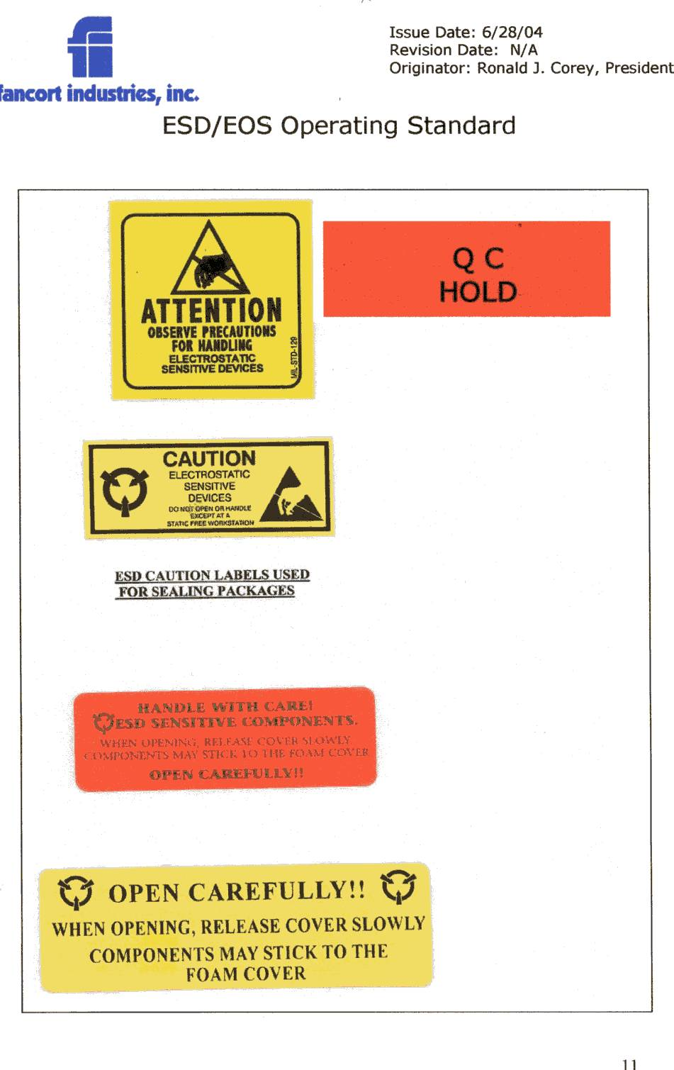

- Calibration

The Local or External Calibration Lab is to perform calibration on ESD/EOS equipment according to the manufacturer’s recommended calibration procedure and the indicated frequency, as a minimum. ESD/EOS equipment shall be included in the local facility’s calibration recall program to ensure regular calibration and record keeping.

- Local Calibration Laboratory shall maintain records on inspections and a listing of the ESD equipment scheduled for inspection under the calibration recall program, where applicable. ESD equipment shall be identified according to local calibration procedures. When external Calibration laboratories are necessary, reports of the calibrations performed shall be forwarded to the local Calibration Laboratory.

- QA Calibration & Verification Procedure

Compliance will be determined by performing both visual and electrical tests. The following procedures will be used, as amended from time to time, for all applicable equipment.

1. Wrist Strap/Table Mat Grounding System Functional Test (see Figure 2.)

- Unsnap male fastener of the wrist strap/table mat from the female snap fastener on the ESD mat.
- Set the Multimeter to RX1 Scale.
- Connect the black (common) meter probe to the ESD workstation’s common ground point.
- Connect the red meter probe to the snap connector at the end of the grounding wire.
- The measured resistance shall be 1 Ohm, or less.
- Repeat steps d. and e. for all remaining banana jacks.
- Set the Multimeter to the RX 100 Scale.
- Connect the red meter probe to the male fastener (located on the wrist strap/table mat.
- The measured resistance shall be 1 Meg Ohm + 1 10K Ohms.

2. Floor Mat/Table Mat Functional Test

- A resistance measurement shall be taken from any three (3) points on the mat to ground using the Mega ohmmeter (see Figure 3.)
- Connect the ground lead (probe) of the meter to the ground point of the mat.
- Place the other probe on the mat to be measured.
- Observe that the resistance value is greater than 10º ohms and less than 10º ohms.
- Repeat this procedure for all remaining ground points.

3. Test/General Equipment (ESD Environment)

- Visually inspect and verify that all test and related ESD equipment are not placed on a conductive ESD mat or workbench, since it could result in a hard grounding of that surface. Equipment that has rubber feet is acceptable.

- Verify that all related equipment is electrically grounded to the equipment’s electrical system or other suitable ground.

- ESD Protective Items Purchase Requirements:

ESD protective materials shall be tested by the vendor before usage at the facilities. The vendors are required to provide proof (to the Local ESD Coordinator/Purchasing) that the materials pass industry standards applicable requirements (see Related References/Procedures Section). Procurement should maintain a list of currently approved ESD protective materials suppliers.

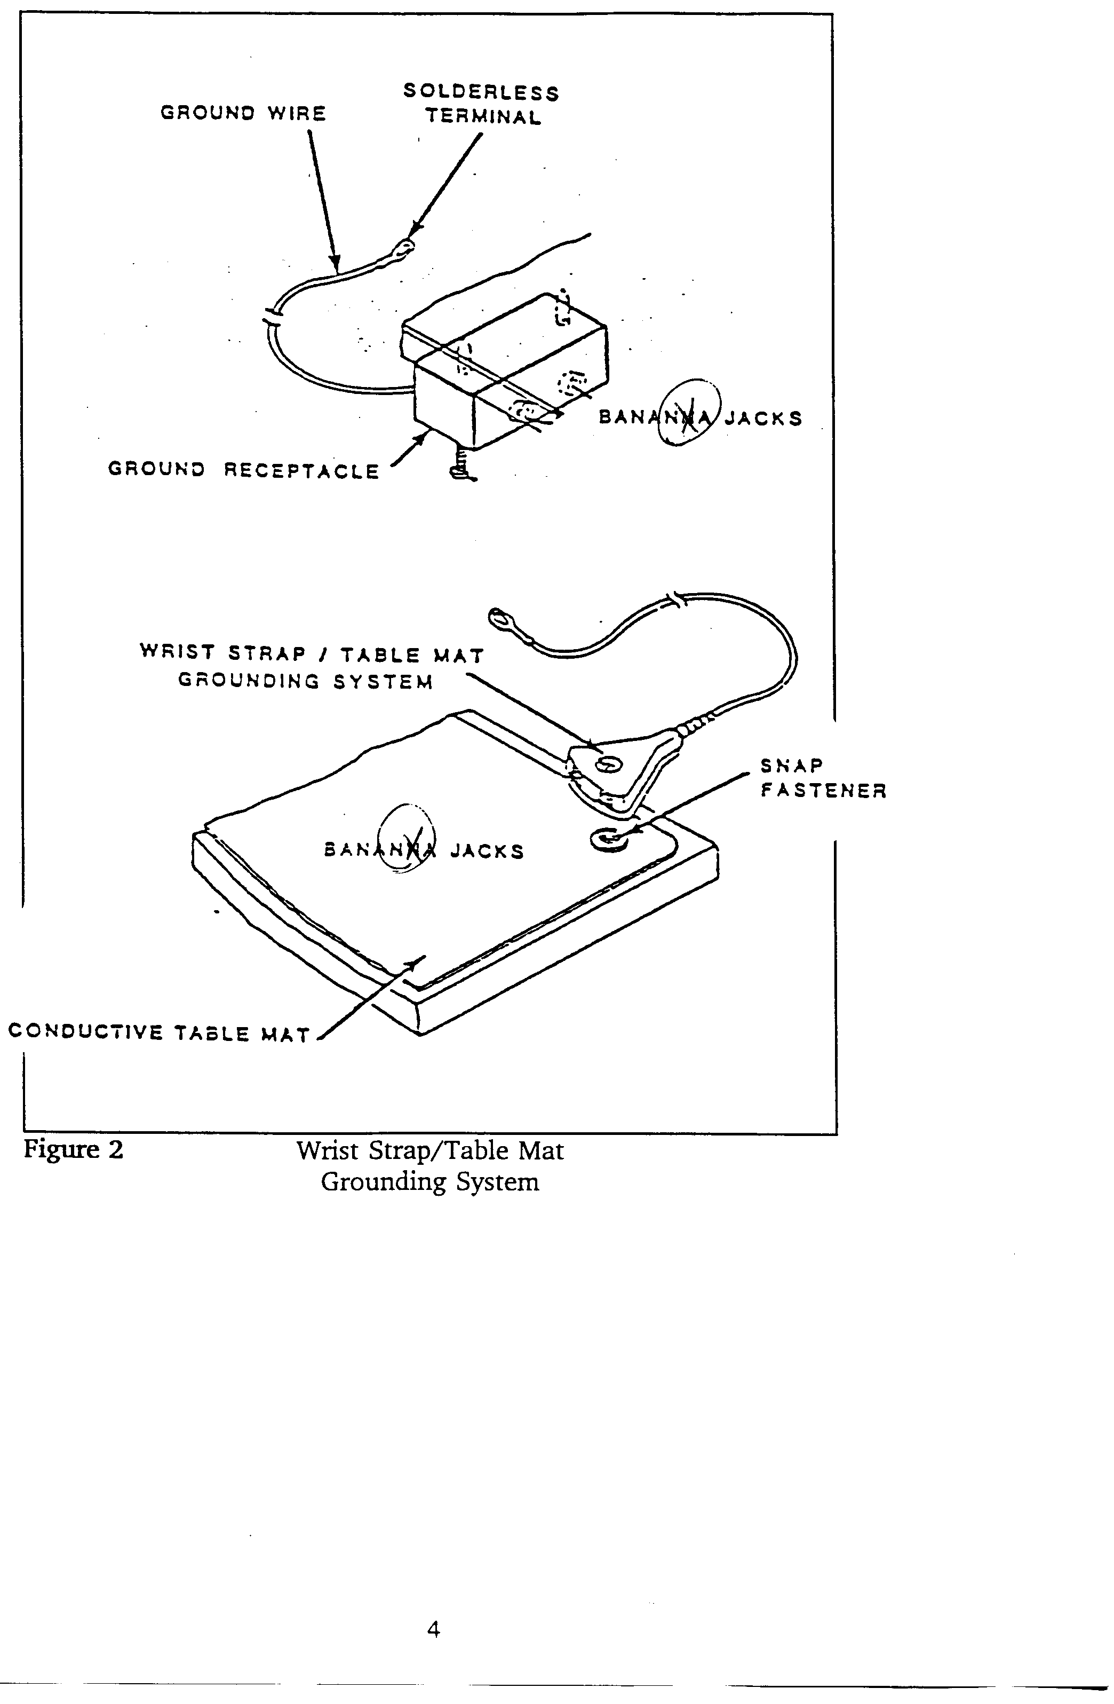

Snap
Fastener

Banana Jacks

Conductive Table Mat

Figure 2 Wrist Strap/Table Mat Grounding System

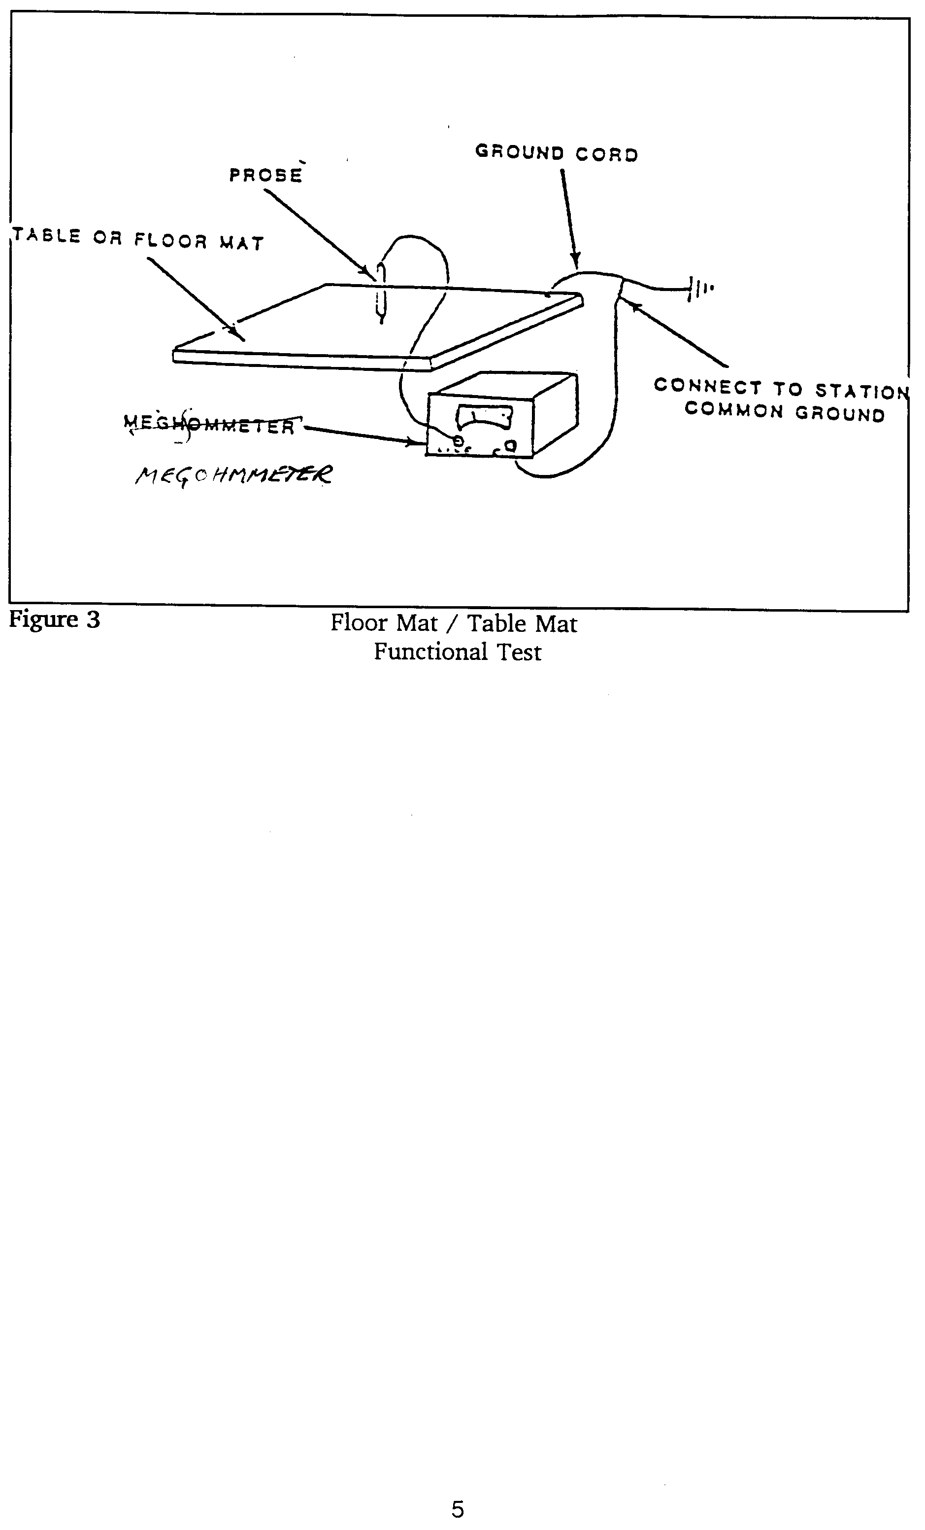

TABLE OR FLOOR MAT

CONNECT TO STATION
COMMON GROUND

MEGOHMMETER

Figure 3 Floor Mat/Table Mat Functional Test

6.8 Training Program:

ESD training and awareness is considered key in addressing ESD/EOS problems. It is necessary that all affected personnel (all those that may be in contact with ESD sensitive products at some point in the manufacturing process) be trained in ESD/EOS basics and mitigation techniques. Affected personnel shall receive a certification upon completion of ESD/EOS training prior to working in the manufacturing environment. Refresher training shall be provided on a regular basis, minimum timing being yearly (see Table 3.)

The content of the training program shall be tailored to meet the requirements of local facility operations. It is the responsibility of the local ESD Coordinator to design a training program to meet the needs of the facility. The ESD/OS Training Program must consists of the following basic elements:

- Basics of ESD/EOS (i.e., demonstrations of static principles and effects of ESD on sensitive components including Failure Analysis),
- ESD Charge Mitigation Measures (i.e., importance of air ionization usage, etc.),
- Instructions on proper usage of ESD protective items,
- Instructions on how to test personal ESD protective items (e.g. wrist straps, footwear, etc.),
- Reaction plans to ESD protective items failures.

General Rules:
None

- Record Keeping: Records are maintained in accordance with Corporate Retention Schedule requirements.

LIST OF QUALITY RECORDS

  - ESD/EOS Operating Standard Assessment Survey.

HOLDER OF QUALITY RECORDS

- ESD Coordinator

RECORDS OF REVISION

Date | Description | Pages Affected | Authorized By
04/18/97 | Initial DRAFT Version 1.0 | All | Manufacturing, Engineering and Process Support Office Manager
08/22/97 | Release Version 1.0 | All | Manufacturing, Engineering

6.9 ESD/EOS Operating Standard Assessment Survey:

Facility Name: Date:

Local ESD Coordinator Name:

Auditing Team Name(s):

Section A – Organizational Structure:

Yes | No
 |  | Does the facility have a Local ESD Committee?
 |  | Do the responsibilities match those outlined in the ESD/EOS Operating Standards? Please describe.
 |  | Does the facility have a Local ESD Coordinator?
 |  | Do the responsibilities match those outlined in the ESD/EOS Operating Standards? (Obtain a copy of job description, if available)
 |  | Does the facility have an Auditor?
 |  | Do the responsibilities match those outlined in the ESD/EOS Operating Standards?
 |  | Does the facility have Group Leader(s) assigned by line/area or Non-Manufacturing Lab Supervisors?
 |  | Do the responsibilities match those outlined in the ESD/EOS Operating Standards?
Section B – List of ESD Sensitive Device Types:
 |  | Does the facility have access to the List of ESD Sensitive Device Types?
 |  | Has the facility identified the components used at that location from the subject list?
 |  | Are the extra precautions indicated in Table 1 (Area Classification) being taken to handle such devices?
Section C – Area Classification
 |  | Do you have Area Classifications? Are these based on the sensitivity of the components used in the different areas, or any other criteria?
 |  | Are ESD/EOS Association Standards followed when using ESD Signs and Area Labels? Or any other locally (nationally recognized) standards?
 |  | Are wrist/heel and/or footwear testing areas labeled?
Section D – ESD Protected Area:
 |  | Has a local Non-Essential Items Listing been identified and displayed or provided to personnel handling ESDS components?
Section E – Compliance Verification Tables:
 |  | Are the Compliance Verification Reference Tables in the ESD/EOS Operating Standards being followed?
 |  | Are ESD Association Standard Procedures used for materials checking? Which Standards are used?
 |  | Are materials checking records being kept? Provide samples.
 |  | Are there formally documented and implemented reaction plans used at the facility. Provide samples.
Section F – Packaging Requirements:
 |  | Are the types of in-house packaging used in the facility consistent with the ESD/EOS Operating Standards?
 |  | Are the types of Supplier packaging used in the facility consistent with the ESD/EOS Operating Standards?
Section G – Equipment Required for Effective ESD Protection:
 |  | Does the Facility have the required and sufficient ESD Measurement Equipment as indicated in the ESD/EOS Operating Standards?
 |  | Calibration: Does the Facility include the ESD Equipment in the local Calibration Tracking Database? Is it being done internally, or externally? If internally, does the Facility have all necessary equipment to do so?
 |  | Are the manufacturers recommended calibration frequencies being followed?
Section H – ESD Protective Items Purchase Requirements:
 |  | Is the ESD Protective equipment qualified before usage at the Facility? Is qualification documented?
 |  | Does the Facility have an ESD Protective equipment Preferred Vendor’s List?
Section I – Training Program:
 |  | Is there a formal ESD/EOS Training Program in place? How is it administered and on what frequency?
 |  | Is the content consistent with the Facility’s needs and ESD/EOS Operating Standard?
 |  | Are there refresher-training courses?
Rating Scale:
The rating scale is intended to provide all affected personnel with an indication of compliance to the ESD/EOS Operating Standards at the facility level. It is not to be considered or used as an absolute measure of the effectiveness of the implemented systems given its confined scope. This rating is not to be used to compare facilities, given the differences in operational structures and local needs.
Green: 30-25 Yellow: 24-15 Red: 0-14

